**Project Title:** ToyCraft Tales: tableau's vision into toy manufacturer data

**Track:** Data Analytics with Tableau

**Team ID :** LTVIP2025TMID51026

**Team Lead:** MUDIGONDA HARSHITHA SRI

**Mail Id :** [harshithamudigonda1@gmail.com](mailto:harshithamudigonda1@gmail.com)

**Team Members:**

* DEPURI SNEHA
* TUPAKULA SAI LAHARI
* YALAKAPATI GURU DIKSHIT

**Email Id's:**

* [228A1A0406@risekrishnasaiprakasam.edu.in](mailto:228A1A0406@risekrishnasaiprakasam.edu.in)
* [228A1A0535@risekrishnasaiprakasam.edu.in](mailto:228A1A0535@risekrishnasaiprakasam.edu.in)
* [yalakapatigurudikshith@gmail.com](mailto:yalakapatigurudikshith@gmail.com)

# Submitted By:

* MUDIGONDA HARSHITHA SRI
* Rise Krishna sai prakasam group of institutions, ongole
* Roll No: 228A1A4420

# Submitted To:

SmartBridge

# Abstract :

This project utilizes Tableau to explore the toy manufacturing industry through interactive data visualizations. By analyzing historical sales, production patterns, and demographic data, it uncovers key market trends and consumer preferences. Seasonal analysis reveals shifts in demand during holidays and summer months. Demographic insights highlight varying toy preferences across age, gender, and location. Regional comparisons showcase product performance differences across geographies. These insights guide strategic planning, product development, and marketing efforts.The project empowers manufacturers to enhance competitiveness and align offerings with market demands.

# Introduction :

This project leverages Tableau to analyze the toy manufacturing industry through data-driven visualizations. It focuses on uncovering market trends, production patterns, and consumer preferences. By exploring historical sales, demographic insights, and regional performance, the project aims to support strategic decision-making. Interactive dashboards provide clarity on seasonal demands and target markets. Ultimately, it helps manufacturers align offerings with evolving market needs.

# Problem Statement:

• Toy manufacturers lack clear insights into seasonal sales trends, impacting production and marketing strategies.

• Understanding of consumer preferences across diverse demographic segments remains limited.

• Regional variations in product performance are not effectively analyzed or utilized.

• Absence of interactive, data-driven tools hinders informed strategic decision-making.

**ARCHITECTURE:**

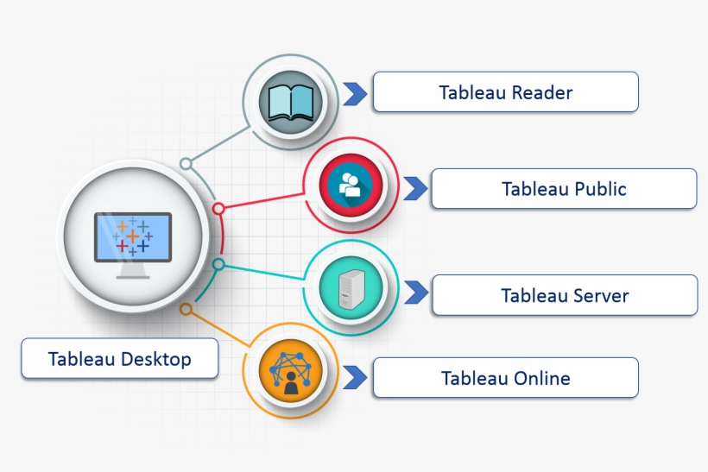

**PREREQUISITES :**

**Accessible and Clean Dataset:** A comprehensive dataset containing historical sales, product details, customer demographics, and regional information is paramount.

**Tableau Desktop License**: Access to Tableau Desktop is essential for creating the interactive visualizations and dashboards.

**Basic Tableau Proficiency**: Familiarity with Tableau's interface, data connections, calculated fields, and dashboard creation is required.

**Data Warehousing/Database Knowledge (Optional but Recommended):** Understanding of data structures (e.g., star schema) and SQL for efficient data preparation can be beneficial.

**Domain Knowledge of Toy Industry**: A basic understanding of toy categories, seasonality, and consumer behavior within the industry will aid in insightful analysis.

**PRIOR KNOWLEDGE :**

**Tableau Fundamentals (Connecting Data & Basic Vizzes):** Understanding how to connect to various data sources (CSV, Excel, databases), drag and drop fields, create basic charts (bar charts, line graphs), and understand dimensions vs. measures.

* :: <https://www.tableau.com/learn/training>

**Data Storytelling & Dashboard Design Principles:** Knowing how to effectively communicate insights through visualizations, choose appropriate chart types, and design user-friendly, impactful dashboards.

* :: <https://www.tableau.com/visualization/data-visualization-best-practices>

**Calculated Fields and Parameters in Tableau:** For advanced analysis like year-over-year growth, percentage change, and creating dynamic filters, knowledge of calculated fields and parameters is crucial.

* :: [https://help.tableau.com/current/pro/desktop/en-us/functions_functions_calculatedfields.htm](https://www.google.com/search?q=https://help.tableau.com/current/pro/desktop/en-us/functions_functions_calculatedfields.htm)

**Understanding of Time Series Analysis:** For analyzing seasonal trends and historical sales data, a basic grasp of time series concepts and how to handle date dimensions in Tableau is valuable.

* :: [https://help.tableau.com/current/pro/desktop/en-us/dates_understand.htm](https://www.google.com/search?q=https://help.tableau.com/current/pro/desktop/en-us/dates_understand.htm)

**Market Research & Consumer Behavior Basics (Toy Industry Specific):** Familiarity with common market segmentation, consumer purchasing drivers, and typical trends within the toy sector will help interpret the data meaningfully.

* :: <https://www.credenceresearch.com/report/toy-market> (Note: This is a market research report; the full content may require purchase, but the overview provides valuable context.)

**Geographic Visualization in Tableau:** For analyzing regional product performance, knowing how to create and utilize map-based visualizations is essential.

* :: <https://help.tableau.com/current/pro/desktop/en-us/maps_build.htm>

**Tableau Community and Resources:** Awareness of the Tableau Public gallery, community forums, and online courses for inspiration, troubleshooting, and continuous learning.

* :: <https://www.tableau.com/dashboard/dashboard-examples>

1. **PROJECT OBJECTIVES**

project objectives for the Toy Manufacturers' Data Exploration and Visualization Project:

1. **Identify Key Market Trends:** To analyze historical sales data to discern evolving market demands, growth areas, and declining toy categories, particularly focusing on seasonal fluctuations to optimize product release and marketing strategies.
2. **Uncover Consumer Preferences by Demographics:** To develop interactive visualizations that reveal how toy preferences vary across different age groups, genders, and geographic locations, enabling targeted product development and marketing campaigns.
3. **Assess Regional Product Performance:** To visualize sales performance of various toy categories across different regions or countries, identifying areas of strong demand and informing optimized distribution and inventory management strategies.
4. **Enhance Strategic Decision-Making:** To provide an intuitive and interactive Tableau dashboard that empowers marketing, sales, and product development teams with data-driven insights for more effective strategic planning.
5. **Improve Market Competitiveness:** To ultimately enable the toy manufacturer to align product offerings with consumer demands, capitalize on market opportunities, and optimize operations to gain a competitive edge in the industry.
6. **PROJECT FLOW**

To accomplish this, we have to complete all the activities listed below,

**Data Collection & Extraction from Database**

o   Collect the dataset,

o    Storing Data in DB

o   Perform SQL Operations

o   Connect DB with Tableau   Data Preparation

o   Prepare the Data for Visualization

**Data Visualizations**

o   Number of  Unique Visualizations

**Dashboard**

o   Responsive and Design of Dashboard

**Story**

o   No of Scenes of Story

**Performance Testing**

o   Amount of Data Rendered to DB ‘

o   Utilization of Data Filters

o   No of Calculation Fields

o   No of Visualizations/ Graphs

**Web Integration**

o   Dashboard and Story embed with UI With Flask

**Project Demonstration & Documentation**

o   Record explanation Video for project end to end solution

o   Project Documentation-Step by step project development procedure

**Project Structure**

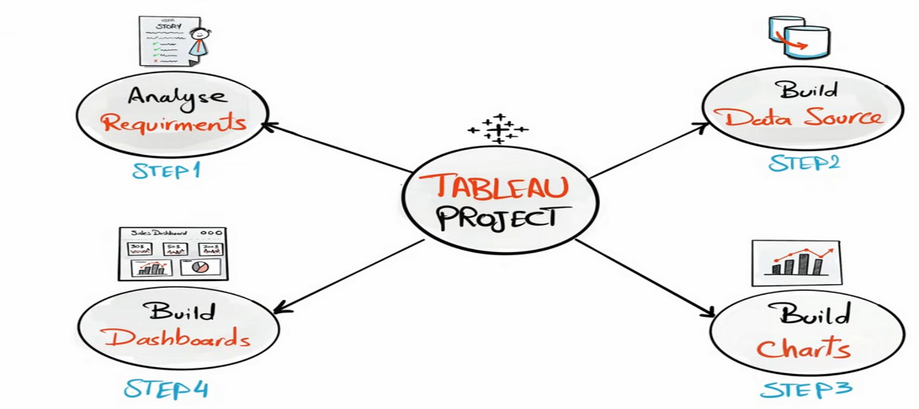

**Analyze Requirements**: Define project goals and specific business questions with stakeholders.

**Build Data Source:** Prepare and connect clean, structured data suitable for Tableau analysis.

**Build Charts:** Create individual visualizations to represent specific data insights.

**Build Dashboards:** Combine multiple charts into interactive dashboards for comprehensive data exploration

**DATA COLLECTION AND PREPARATION:**

For the Toy Manufacturers' Data Exploration and Visualization Project, Data Collection and Preparation are critical foundational steps. Here's how they would be addressed in 7 lines:

1. **Data Identification & Sourcing:** Identify all relevant internal data sources, including historical sales records, product catalogs, customer demographics, and potentially production logs or marketing spend data.
2. **External Data Integration:** Explore incorporating external data such as market trends reports, economic indicators, or competitor sales data (if available) to enrich the analysis.
3. **Data Extraction:** Extract raw data from various systems, which could involve querying databases (SQL), exporting from CRM/ERP systems, or consolidating data from spreadsheets.
4. **Data Cleaning:** Perform rigorous data cleaning to handle missing values, correct inconsistencies (e.g., product naming variations), remove duplicates, and standardize data formats (e.g., dates, units).
5. **Data Transformation:** Transform raw data into a structured format suitable for analysis in Tableau, which includes creating calculated fields (e.g., profit margin), aggregating data to appropriate levels (e.g., monthly sales), and joining disparate datasets.
6. **Data Modeling:** Design a logical data model (e.g., star schema) within the data warehouse or directly in Tableau to ensure efficient querying and accurate relationships between tables.
7. **Data Loading & Validation:** Load the prepared and transformed data into Tableau or a data warehouse connected to Tableau, followed by thorough validation to ensure data accuracy and completeness for reporting.
8. **Metadata Management:** Establish clear documentation for data definitions, sources, transformations applied, and update schedules to maintain data integrity and understanding across the project.
9. **Data Security & Privacy:** Implement measures to ensure the security and privacy of sensitive data (e.g., customer demographics), adhering to relevant regulations and internal policies during all stages.
10. **Automated Data Pipelines (Scalability):** Where feasible, design and implement automated processes for data extraction, transformation, and loading to ensure consistent, timely data refreshes and reduce manual effort for future updates.
11. **Performance Optimization:** Optimize data structures and queries, potentially involving indexing or partitioning, to ensure that Tableau dashboards perform efficiently, especially with large datasets, providing a responsive user experience.

**COLLECTING THE DATASET:**

It is the most crucial aspect that makes algorithm training possible. So, this section allows you to download the required dataset.

Activity 1: Download the dataset

There are many popular open sources for collecting the data. Eg: kaggle.com, UCI repository, etc.

In this project, we have used 28 classes of fruits and vegetables data. This data is downloaded from kaggle.com or can be connected by using API. Please refer to the link given below to download the dataset.

**Link:**  [Dataset](https://www.kaggle.com/datasets/muhammad0subhan/fruit-and-vegetable-disease-healthy-vs-rotten)

As the dataset is downloaded. Let us read and understand the data properly with the help of some visualization techniques and some analyzing techniques.

Note: There are several techniques for understanding the data. But here we have used some of it. In an additional way, you can use multiple techniques.

1. **project Visualization**

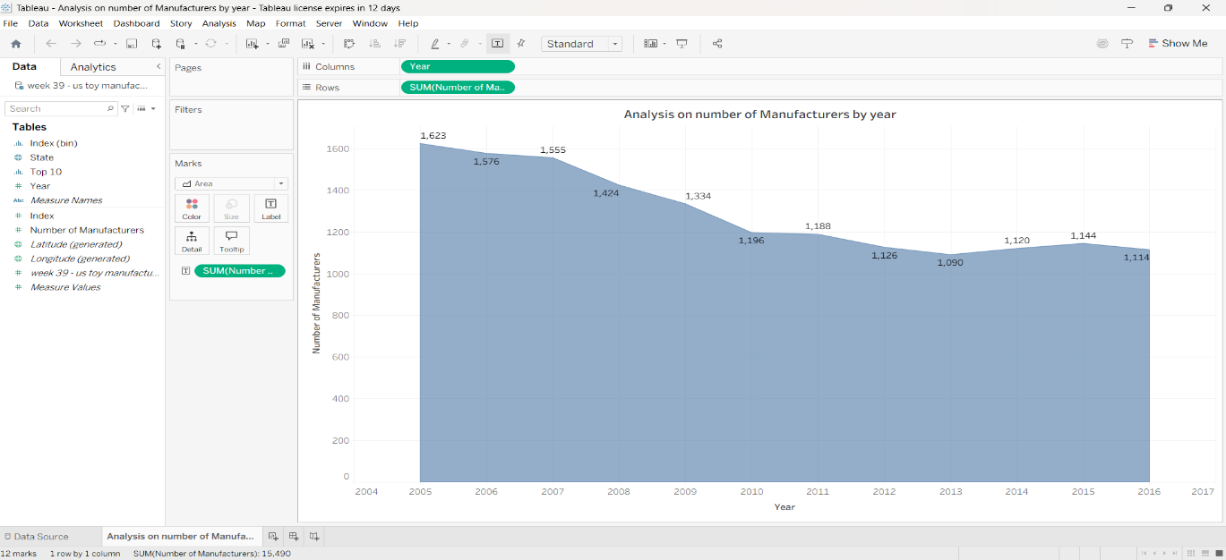**1. Analysis on number of Manufacturers by year**

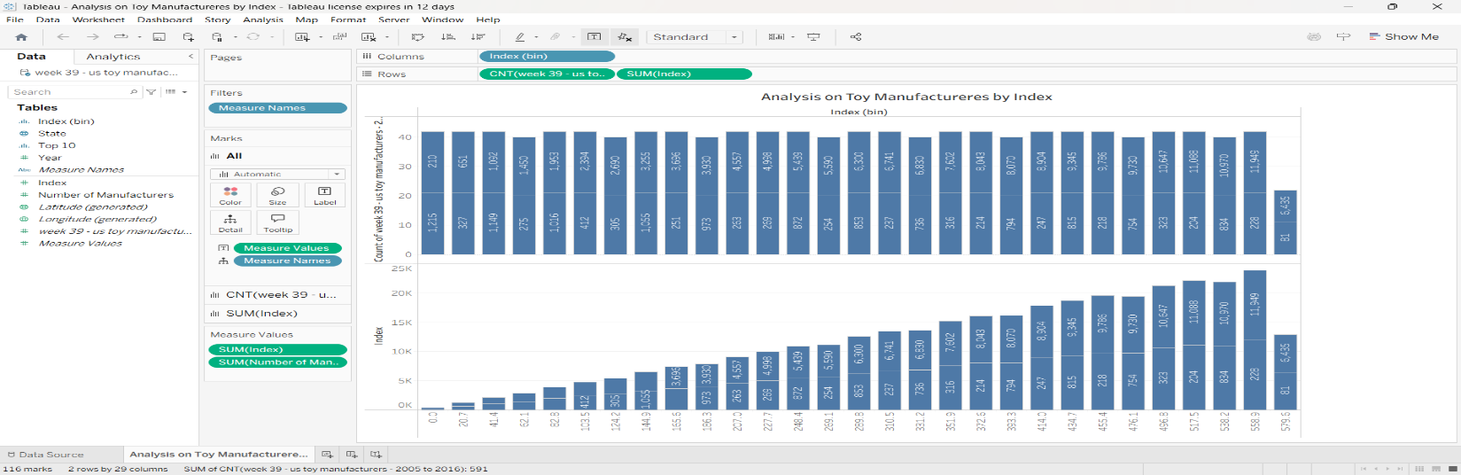 **2. Analysis on Toy Manufacturers by Index**

**3. Analysis on Toy Manufactures in US by Index**

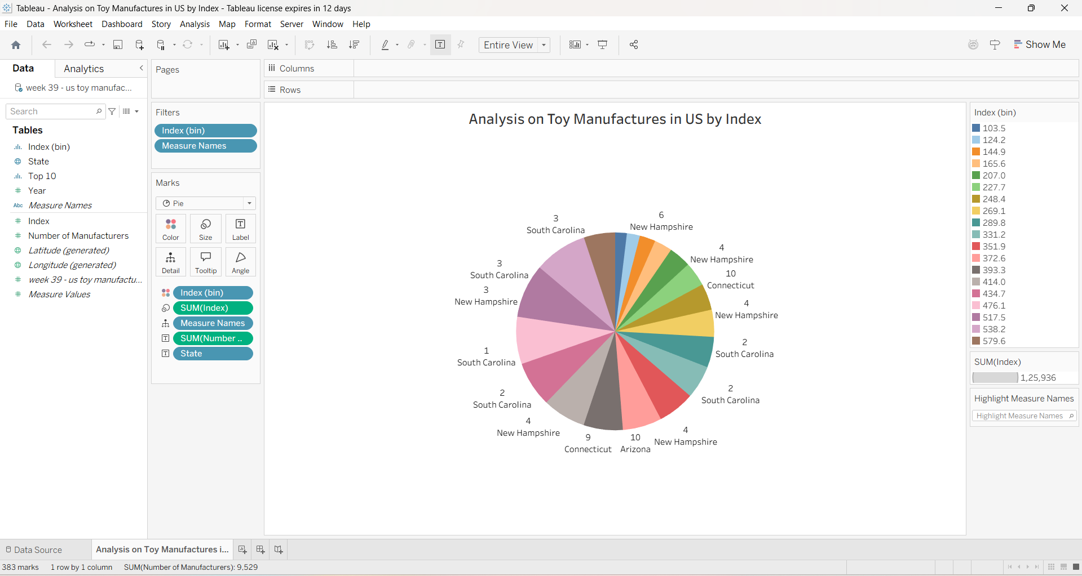

**4.Analysis on Toy Manufacturers**

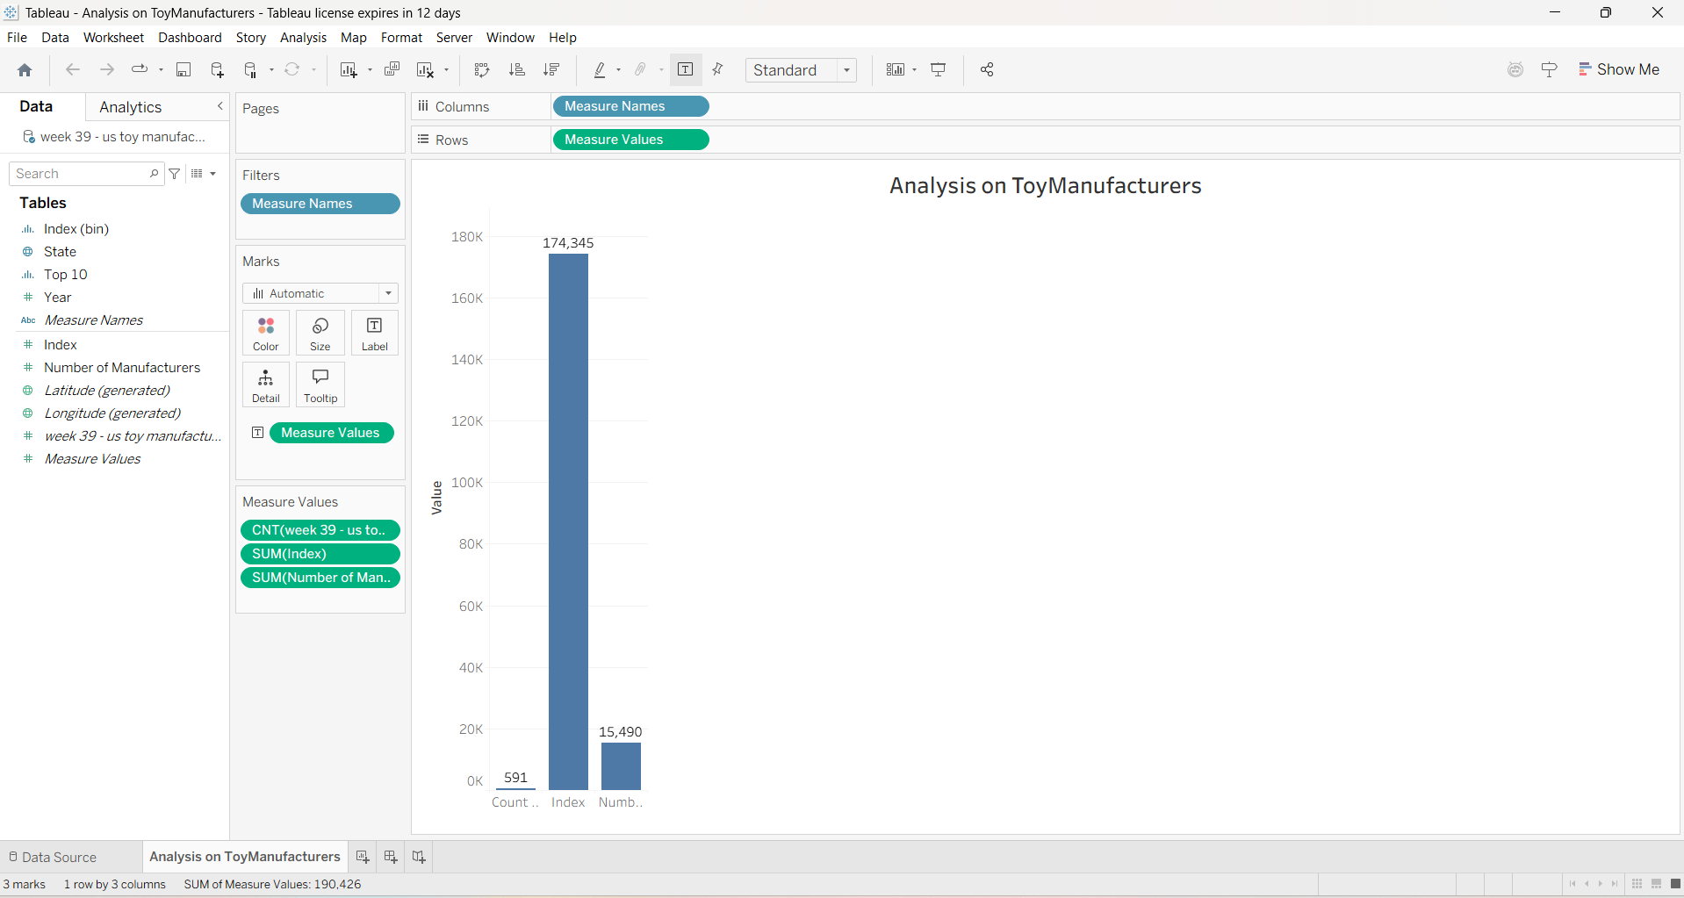

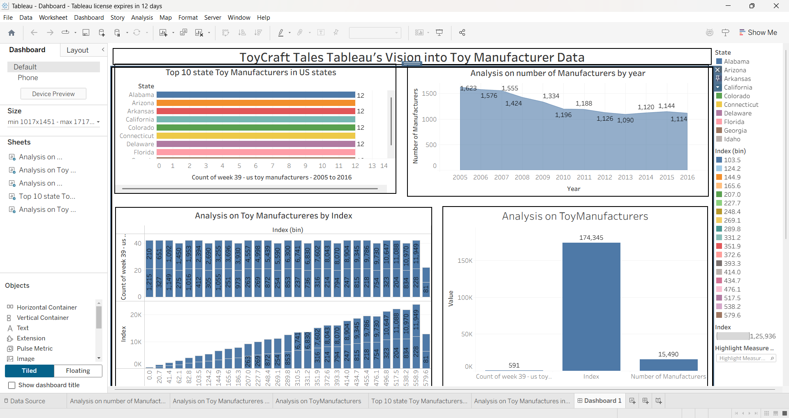

Dashboard

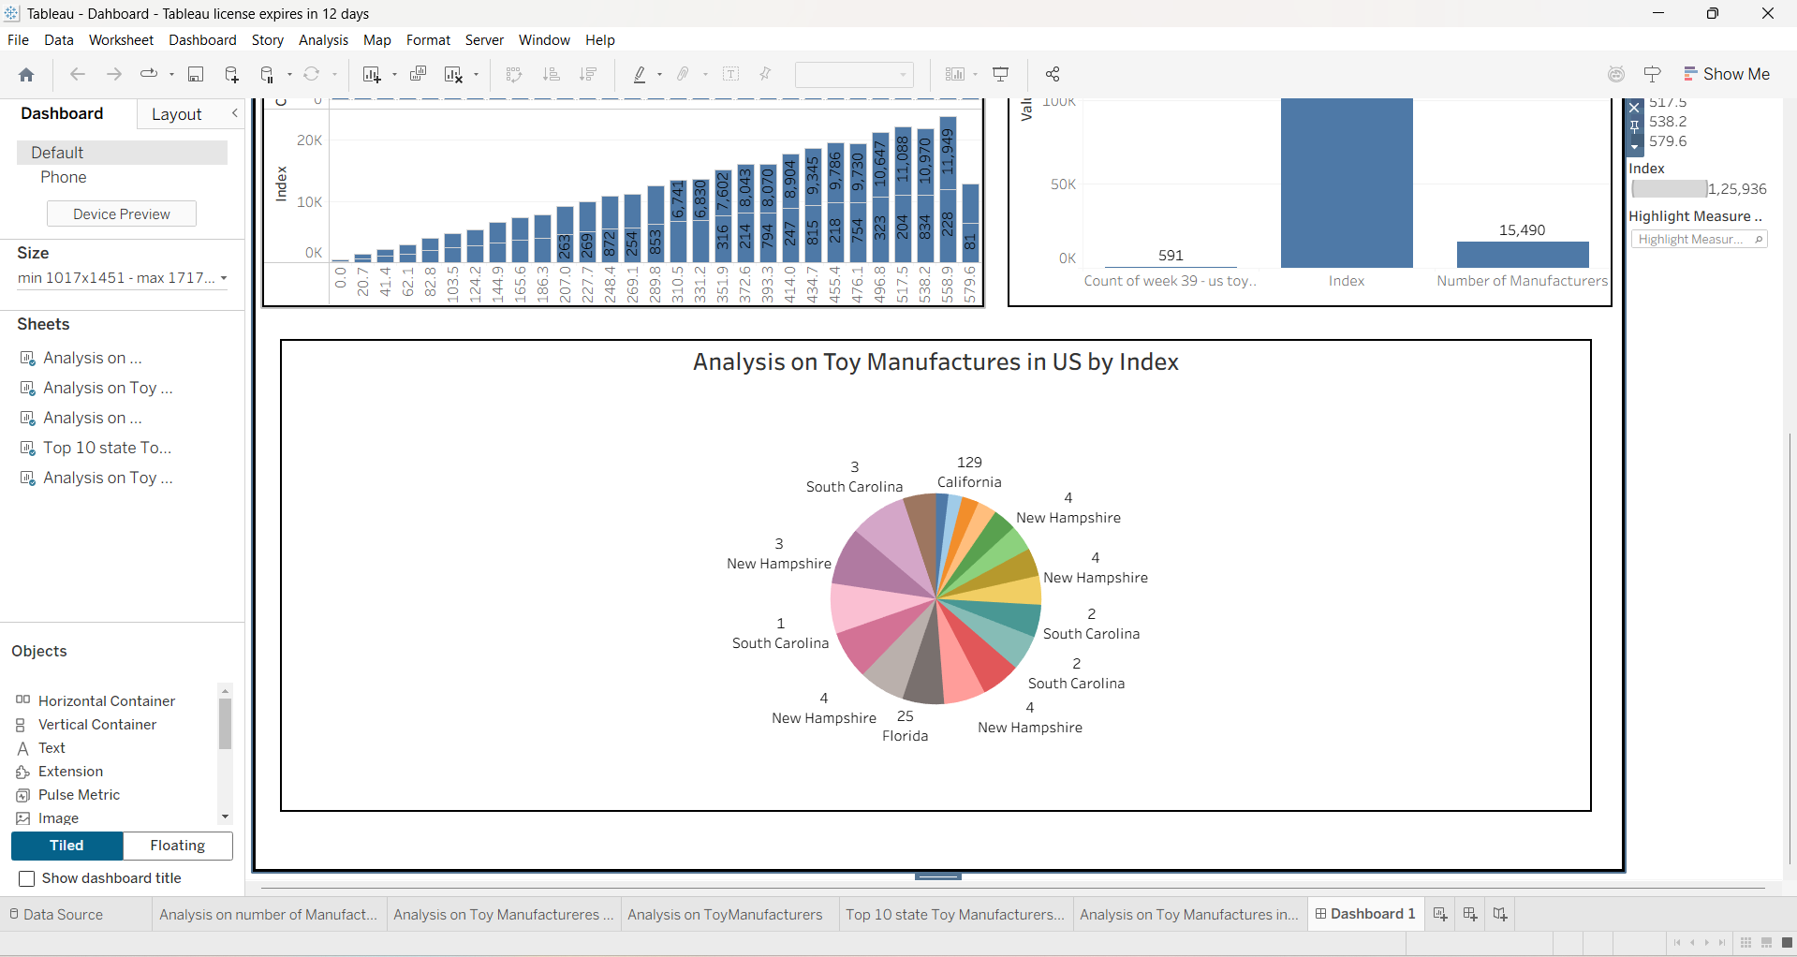

**SAVING THE MODEL:**

Finally, we have chosen the best model now saving that model

# Scenarios of Application:

# Market Trend Analysis for Seasonal Products: Focuses on visualizing historical sales to identify toy performance patterns across different seasons and holidays.

# Objective: Enable manufacturers to align production and marketing with peak demand periods for seasonal products.

# Consumer Preference Analysis Across Demographics: Examines consumer behavior by analyzing toy preferences based on age, gender, and location.

# Objective: Provide insights for tailoring product development and marketing campaigns to specific demographic segments.

# Product Performance Comparison Across Regions: Analyzes sales data geographically to identify which toy categories excel in particular regions or countries.

# Objective: Optimize distribution channels and inventory management strategies based on regional demand variations.

# Overall Goal: Empower toy manufacturers with data-driven insights for strategic decision-making and enhanced market competitiveness.

# Tools and Technologies Used:

**Tableau Desktop:** The primary tool for connecting to data sources, building interactive visualizations, dashboards, and stories.

**Tableau Server / Tableau Cloud:** For publishing, sharing, and securing the developed dashboards, enabling broad access and collaboration across the organization.

**SQL Databases (e.g., PostgreSQL, MySQL, SQL Server):** Likely used as the backend for storing raw and transformed sales, product, and customer demographic data.

**ETL Tools (e.g., Python with Pandas, Talend, Apache NiFi):** For extracting data from various sources, cleaning it, transforming it into a structured format, and loading it into the data warehouse or directly into Tableau.

**Spreadsheets (e.g., Microsoft Excel, Google Sheets):** Potentially used for initial data collection, small datasets, or temporary staging of data before full integration.

**Data Warehouse (e.g., Snowflake, Google BigQuery, Amazon Redshift):** A centralized repository for optimized, structured data, providing a performant source for Tableau.

**Version Control (e.g., Git):** (Optional but recommended) For managing dashboard files, calculated fields, and data preparation scripts, especially in a team environment

# Concepts and Prerequisites:

# A. Core Concepts

# Data-Driven Decision Making (DDDM)

# Business Intelligence (BI)

# Data Visualization Principles

# Time Series Analysis

# Market Segmentation

# Comparative Analysis

# Data Storytelling

# B. Technical Prerequisites

# Accessible and Clean Dataset

# Tableau Desktop License

# Basic Tableau Proficiency

# Data Warehousing/Database Knowledge

# Computational Resources

# Collaboration Platform

# C. Domain Prerequisites

# Domain Knowledge of Toy Industry

# Defined Business Questions

# D. Data Management Prerequisites

# Data Governance Plan

# Methodology:

Dataset: <https://www.kaggle.com/datasets/thedevastator/toy-manufacturers-in-us-states?select=Week+39>

Collect and consolidate toy industry data, including sales, production, demographics, and regions**.**

# Clean and preprocess data using ETL tools to ensure accuracy and consistency.

# Store integrated data in a centralized data warehouse for efficient access.

# Use Tableau to connect with the data warehouse and begin dashboard development.

# Create visualizations focused on seasonal trends, demographic preferences, and regional performance.

# Enable interactivity in dashboards for dynamic filtering and deeper analysis.

# Use insights to inform strategic decisions in production, marketing, and distribution.

# System Architecture:

# Data Ingestion Layer: Gathers raw data from diverse sources like sales, customer, and product databases.

# Data Transformation (ETL): Cleans, transforms, and standardizes data, preparing it for analytical use.

# Centralized Data Storage: A Data Warehouse or Data Mart serves as the optimized repository for structured and historical data.

# Tableau Desktop: Connects to the prepared data for building interactive visualizations, dashboards, and reports.

# Tableau Server/Cloud: Publishes and shares the created dashboards securely for enterprise-wide access.

# User Access Interface: Provides a web-based platform for business users to interact with and consume insights.

# Strategic Decision Support: The entire system empowers stakeholders to make data-driven decisions on market trends, consumer preferences, and product performance.

# Observations:

**A. Market Trends & Evolution**

* Overall Industry Growth/Decline
* Key Growth/Declining Toy Categories Over Time
* Emerging Market Demands
* Impact of Economic Cycles on Toy Sales/Manufacturers

**B. Seasonal Product Performance**

* Peak Sales Periods for Specific Toy Categories
* Off-Season Demand Patterns
* Effectiveness of Holiday-Specific Product Launches

**C. Consumer Preferences & Demographics**

* Age-Group Specific Toy Preferences
* Gender-Based Toy Preferences
* Urban vs. Rural Toy Preferences
* Correlation Between Demographics and Toy Category Performance

**D. Regional Product Performance**

* Top-Performing Toy Categories by Region/Country
* Regional Variances in Demand for Specific Toy Types (e.g., educational vs. outdoor)
* Underperforming Regions and Potential Causes
* Regional Distribution Channel Effectiveness

**Result:**

**A. Market Trend Insights**

1. Clear Market Trend Identification

2. Quantified Seasonal Sales Patterns

3. Optimized Production & Marketing Schedules

**B. Consumer Preference Insights**

1. Demographic-Specific Preference Profiles

2. Tailored Product Development Guidance

3. Targeted Marketing Campaign Strategies

**C. Product Performance Insights**

1. Regional Product Performance Benchmarks

2. Enhanced Distribution and Inventory Management

**D. Business Impact**

1. Improved Strategic Decision-Making

2. Increased Market Competitiveness